**AIM: Build Factory Design Pattern on the Model.**

Model chosen: Phishing Detection



**Output:**

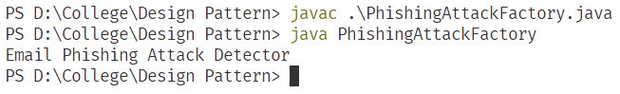

Figure 1: Output of the above program